**GUIDELIINES for “Clinical neuropsychological assessment and rehabilitation" EXAM ONLINE**

**PROF. ROBERTA BIUNDO**

**BEFORE THE EXAM:**

1. **PREPARE YOUR ID, YOU WILL BE ASKED TO SHOW IT IN FRONT OF THE WEBCAM**
2. GO IN MOODLE FROM PC / MAC WITH YOUR CREDENTIALS AND WAIT FOR INSTRUCTIONS FROM THE TEACHER
3. 15 MINUTES BEFORE THE BEGINNING OF YOUR OWN EXAMINATION, CONNECT TO ZOOM **WITH YOUR MOBILE PHONE** WITH THE INSTITUTIONAL ADDRESS (@students.unipd.it) THROUGH THE APPROPRIATE LINK THAT YOU WILL FIND ON MOODLE (SEE “EXAM LINK”). IDENTIFY YOURSELF WITH THE ADDRESS [name.surname@studenti.unipd.it](mailto:name.surname@studenti.unipd.it)
4. WAIT IN THE WAITING ROOM FOR THE TEACHER TO ADMIT ONE AT A TIME TO THE MEETING. THIS OPERATION WILL TAKE TIME BECAUSE IT IS NECESSARY **TO VERIFY THE IDENTITY OF EACH SINGLE PARTICIPANT** BEFORE TO BE ADMITTED IN THE MEETING.

5) ONCE ADMITTED, THE TEACHER MAY ASK EACH STUDENT TO SEE THE WORKSTATION AND THE ROOM WITH THE MOBILE PHONE. AFTER THAT **THE MOBILE PHONE SHOULD BE POSITIONED IN A FIXED POSITION BEHIND OR ASIDE THE WORKSTATION** SUCH AS THE TEACHER IS ABLE TO SEE THE STATION AND THE SCREEN (SEE image below)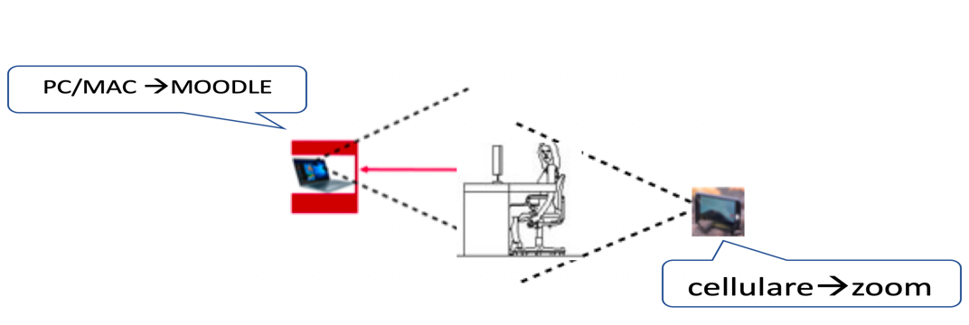

**DURING THE EXAM**

1. EVERYONE WILL HAVE **30 MINUTES** FROM THE MOMENT IN WHICH THE EXAMINATION BEGINS TO ANSWER 25 MULTIPLE ANSWER AND 1 OPEN-ENDED ANSWER QUESTION.
2. THE TEACHER MAY ASK EACH STUDENT TO SEE THE WORKSTATION AND THE ROOM WITH THE MOBILE PHONE
3. **THE ZOOM AUDIO / VIDEO MUST ALWAYS REMAIN ON**, PENALTY CANCELLATION

OF THE EXAMINATION. MAKE SURE YOU HAVE A QUIET ENVIRONMENT. I REMIND YOU THAT THE EXAMINATION IS A LEGAL ACT.

1. EACH STUDENT WILL BE ABLE TO ABANDON THE EXAM SESSION AFTER COMPLETING THE EXAM IN MOODLE BY NOTIFYING THE TEACHER, EVEN IF YOU DECIDE TO WITHDRAW.

**WHAT HAPPENS IN CASE OF TECHNICAL PROBLEMS**

1. **ZOOM DOES NOT WORK:**

- IF THE PROBLEM IS SOLVED SPONTANEOUSLY **WITHIN 3 MINUTES** (E.G., THE VIDEO-IMAGE IS BLOCKED AND THEN UNLOCKED SPONTANEOUSLY), THE EXAMINATION IN MOODLE IS NORMALLY CONTINUED AND IT IS CONSIDERED VALID

- IF THE PROBLEM PERSISTS FOR **MORE THAN 3 MINUTES, THE EXAM WILL UNFORTUNATELY BE CONSIDERED CANCELED.** IF YOU CANNOT RETURN TO THE MEETING, IMMEDIATELY WRITE AN EMAIL TO roberta.biundo@unipd.it TO NOTIFY THE PROBLEM TO THE TEACHER IN REAL TIME

1. **MOODLE DOES NOT WORK:**

- THIS IS A RARE EVENT. ANYWAY, IF THE PROBLEM IS SOLVED SPONTANEOUSLY OR WITH TECHNICAL HELP, THE EXAMINATION WILL CONTINUE WITHIN 3 MINUTES. OTHERWISE, THE EXAM IS CANCELED.

**SUGGESTIONS:**

1. IF POSSIBLE, **USE TWO DIFFERENT NETWORKS** FOR PC (E.G., ADSL OR HOME WIFI) AND MOBILE PHONE (E.G., DATA NETWORK).
2. DO NOT USE THE MOBILE PHONE HOTSPOT (TETHERING) FOR THE PC
3. PREFERABLY USE AN ADSL CONNECTION VIA CABLE. ALTERNATIVE LOCATION (WIRELESS) AS CLOSER AS POSSIBLE TO THE ROUTER.
4. AVOID USING LITTLE STABLE WIRELESS NETWORKS OR IN PLACES WITH POOR SIGNAL (ES, IN DIFFERENT FLOORS / ROOMS).
5. AVOID (AS MUCH AS POSSIBLE) THAT OTHER USERS USE THE HOME NETWORK DURING THE EXAM

**IN CASE OF CANCELLATION OF THE EXAM FOR TECHNICAL PROBLEMS, THERE IS THE POSSIBILITY TO TAKE AN ORAL EXAM (WITHIN A FEW DAYS) TO BE AGREED WITH THE TEACHER.**